Notes for Tonawanda Community Working Group Meeting and Tour
June 25, 2025, Call

Welcome

Thank you for taking the time to come to the sites today. We are truly proud of the progress we have made and now have our focus firmly on the final remediation and closure of the Sites.

I know many of you have been here before and seen a much less pleasant view, but we are moving toward the point of eliminating all evidence of the Tonawanda Coke Corporation from the Town of Tonawanda. The team responsible is expansive:
- Starting with Jon Williams, the visionary and willing volunteer to take on the responsibility to eliminate the hazards and prepare the site for the future.
- John Yensan is overseas, and could not be here today, but as you know he has been tireless keeping the personnel and equipment moving.
- Dan Flanagan is the OSC Project Manager, and he is supported onsite by;
  - Matt Reardon the Superintendent, Brian Rudnick who seems to be everywhere and has all the answers we need about the ongoing work and logistics.
- Ben McPherson and Angie Martin who have been onsite, reviewing hundreds of thousands of pages of work plans, and reports and providing guidance for all aspects of the project.
- The Town of Tonawanda, Jim Hartz, Matthew Sutton and Paul Morrow helping us navigate the requirements of the community.
- The Inventum onsite team; Peter, Corey, Roxanne and Austin;
- The Honeywell team managing the Superfund Sites (108, 109 and 110); Rich, Victoria, Greg, Barbara and Peter.

Surface/stormwater management, the groundwater IRM, CCRs and the remedial designs continue to be the major focus of the work for 3875 River Road (the RITC BCP Site and Site 109).

As before I will touch on the activities in each site.

RITC Brownfield Cleanup Site – 3875 River Road
- Groundwater Management
  - The groundwater collection system is operating well, over 7.5 million gallons of groundwater was treated and discharged to the POTW in 2024. January and February were much drier and only 770,000 gallons were extracted and treated in 2025. Lowest Jan/Feb Flow Rate since we started pumping.
  - The bench-scale testing for the final treatment system design has been completed and submitted to NYSDEC.
  - Groundwater continues to be monitored to ensure impacted groundwater is controlled. In preparation for the remedial design a set of site-wide data was collected.
  - The preliminary layout of the final GWTS is being developed (Slide 2). The bench-scale testing has shown this configuration will provide high water quality for discharge. [The data from the bench-scale testing was submitted to the NYSDEC, the NYSDEC will then define the discharge criteria.]

- Surface Water Management
  - The treatment of surface water continues and we are making progress. The removal of the purifier boxes was the last known above ground source. The North Storm Sewer was removed and the Mansion Sump was mucked out.
  - Each change we make moves us toward the final remedy. This month we will propose the next action to move toward more consistent SWPPP discharge quality.

  - SWPPP
    - The SWPPP is still a primary focus of the work on the Site. This is the only migration pathway from the site and maintaining water quality is a priority.
    - With better weather we can access the south ditch to conduct the annual maintenance to clear the winter accumulations from that system.

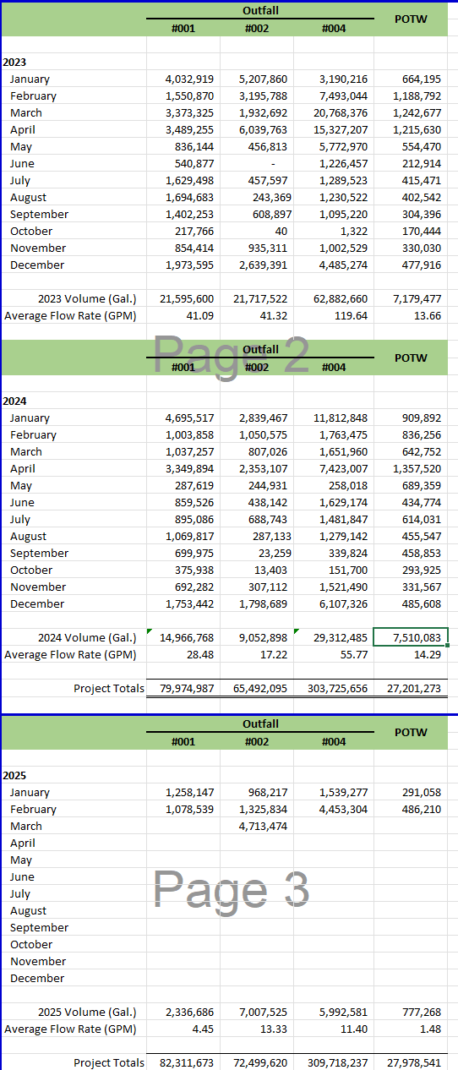
- Demolition
  - A new electrical supply is being installed by National Grid and O’Connell Electric.
  - Following the new supply installation and testing, the old lines can be deenergized and the MG Building, overhand pipe supports, and the metal conveyor structure can be removed (Slide 3).
  - We are trying to repurpose the maintenance/groundwater IRM building for the long-term groundatwer system.
  - The office building will be the final building under the demolition work plan.
  - The concrete was processed and crushed. (Slide 4). The piles are numbered surveyed and sampled to define how they will be managed in the RAWP.

- Interim Remedial Measures (IRMs)
  - The satellite solidification RAWP started this week and is targeting the small areas of viscous tar around the site that must be solidified before final management (Slide 5).

  - The rate of offsite disposal from the BCP Site has dropped, only 8 shipments, 10.75 Tons of C&D and 84 Tons of tires and conveyor belting.
  - Through February24, 2025, 57.4 Million pounds of ACM, Waste and Recyclable materials were shipped. The totals through February 24, 2025:
    - Solid Waste 5,619 Tons
    - Liquids and small containers – 38 Tons
    - Hazardous Waste – 7,630 Tons (no additional Haz)
    - ACM – 3,698 Tons (No additional ACM)
    - Recycled – 11,649 Tons (an additional 128 tons)
- Remedial Action Work Plans
  - The full scale bioremediation RAWP in the ST21 through ST23 secondary containment (Slide 6) is ongoing, we hope to turn the biopiles early March and April. The secondary containment has been pumped out.
  - The Ammonia SCO sampling and analysis have been completed. A data summary report will be submitted in April to define the SCO for the implementation of the RAWP.

- Next Steps (Slide 7)
  - The CCRs for the completed IRMs are being submitted, the AST CCRs have been submitted. The demolition, secondary containment and container CCRs are nearly complete. Now that the rubber removal (84 Tons of waste rubber was found in piles and buried around the east end of the site) has been completed, the surface cleanup CCR can be completed.

Site 109
- The Remedial Action Work Plan will be submitted next week (Slide 8).
- The new power supply is being installed.
- There is earthmoving required to provide the clearance below the new power supply (Slide 9). The poles shown will be moved south to make room for the new entrance road. [Note: was tentatively scheduled in January but a few delays and then National Grid hit an unmarked abandoned communications cable along River Road that set it back another few weeks.]

3821 River Road (aka Plastics) (Slide 10)

- The Supplemental RI Work Plan has been approved. Sampling is scheduled foe April and May.
- The tank management plan has been approved, the are being decontaminated and deconstructed. (Slide 11)
- A draft Phase II RI Work Plan has been prepared and comments from NYSDEC and NYSDOH are expected.

Site 108 (3800 River Road) (Slide 12)

- Large areas of Site 108 were obstructed for the 2024 topographic mapping, the site was cleared last fall and a new topographic map was prepared last month filling a number of data gaps.
- The Feasibility Study for Site 108 has been submitted. The FS required to separate analyses; upland and Niagara River. The FS Report is structured in that way, then a summary of the recommended remedial action is provided in the summary.

River Road Bridge (Slide 13)
- The draft demolition plan for the NYSDOT was completed and submitted. Based on the NYSDOT responses. The issue is there is no viable owner of the bridge, it was not part of the RITC purchase so legally it belongs to TCC. NYSDOT requires that the owner apply for a demolition permit.

Bit of a Rough One, But Spring is Here (Slide 14)
- Wind and ice were rough at the site this winter, but time to move on. March is supposed to go out like a Lamb after coming in like a Lion….HMMMM.

